Doc Writer: Rajanidhi Rajasekeran Doc Date: Dec 21, 2015.

Application or System Name
De-ENROLLMENT PROCESSES
General Overview
Customer Requested De-enrollment : This is handled using Enrollment Center where the CE User should click on the de-enroll button next to the DPP enrolled program, a popup will be shown to confirm de-enrollment. On confirming de-enrollment will be performed.
Customer Move-Out: The customer moves-out of the DPP active Service delivery point, thereby de-enrolling from the DPP program. In this case an interaction record will be created and enrollment table will be updated with the de-enrollment status.
Customer Request into another Program: Enrollment into another Customer Program that necessitates DPP de-enrollment. For all mutually exclusive programs, before the enrollment into another program is perform, CE User has to first de-enroll the customer from DPP, for which the CE user will use the enrollment center to do the de-enrollment.

Technical Design:
Function Modules:
ENHANCEMENT DESIGN SPECIFICATIONS:
Enhancement Requirements
Number | Description of Requirement
1 | Creation of DPP component for De-enrollment process
2 | Creation of Genil Component for De-enrollment process
3 | Creation of logic to see if DPP program was selected for Enrollment in the Enrollment Center, navigate to the DPP enrollment component for de-enrollment

Go to Component work bench bsp_wd_cmpwb, here we have to create a new component and the component name is ZDPP_ENROLLMENT.
In this go to runtime repository it consist of a main window
Go to windows->ZDPP_ENROLLMENT/Mainwindow
Go to the method Inbound Plugs-> IP_DEENROLL_CPP / IP_DEENROLL_PTR

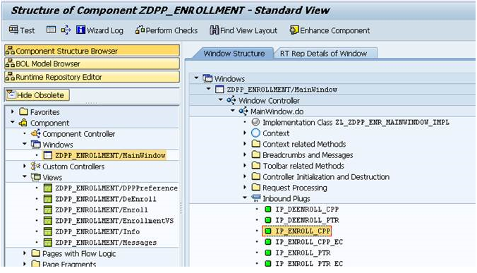

Go to Method-> ip_deenroll_cpp/ip_deenroll_ptr
METHOD ip_deenroll_cpp.
* Set Description.
CLEAR gv_description.
gv_description = 'CPP De-Enrollment Process'.
* Load PGM Data
load_pgmdata_fromec( iv_collection ).
* Process De-enrollment
process_deenroll_ec(
EXPORTING
iv_zpgmtype = 'CPP' " Interface Program Type
iv_zenrl_type = '2' " Enrollment Type
).
ENDMETHOD.
In this method the below process is performed
- Load Process description
- Load the enrollment object passed by the enrollment center
- Load ProgramEnroll entity passed from the enrollment center
- Load ProgramEnrolled entity passed from the enrollment center
- Perform de-enrollment process
- Perform pre-check to see whether business partner and business agreement is confirmed
- Show confirmation popup to confirm de-enrollment
- On confirmation, perform de-enrollment
- Execute rate change using method ExecuteDeEnrollment, internally Fm Z_DLA_RATE_CHANGE is used to change the rate.
- Change the status of enrollment record to de-enrolled
- Send outbound to DRMS informing about the de-enrollment

Go to the transaction code GENIL_MODEL_BROWSER.
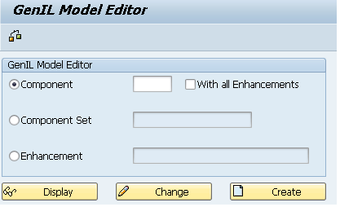
In the above Genil Model Editor and the Component is ZENROL

Here we can see the Model objects-> Root Objects->Root Objects Enrollment.

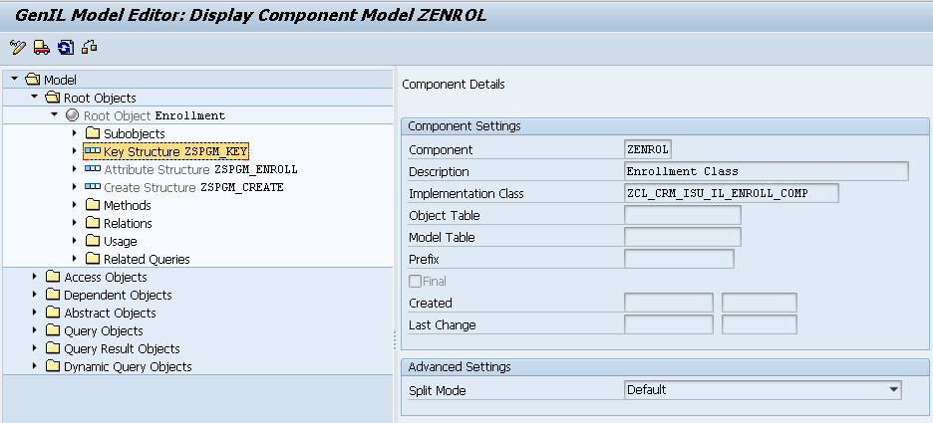

In this we can see key structure ZSPGM_KEY in this structure we can see enrollment business partner number, Enrollment contract account number, Enrollment program type and Enrollment requested date.
Also we can see the attribute structure ZSPGM_ENROLL it Consist of all the program enrollment structure
Create Structure ZSPGM_CREATE we can see the components as enrollment business partner number, Enrollment contract account number, Enrollment program type, Enrollment requested date and Enrollment service delivery point ID.

Go to the transaction SE24 is a class builder ZCL_CRM_ISU_IL_ENROLL.
Here go to the method->IF_CRM_IU_IL_ABSTR_ROOT~CREATE in this ZISU_IL_ENROLL_CREATE is a function module in this function module we are creating a function group ZCRM_PGMENROLLMENT in this Function Group we can see some function modules consist of all the function knowledge for create enrollment like Create Save which is used create a customer It will create an object checks for the order exists in the app buffer it will the entries in the enrollment table if no error exists and then send the confirmation to EV.
System Diagram
Technical Parts Inventory
-------Name------- | ----Description---- | -----Location----- | ----Environment---
ZDPP_ENROLLMENT | Component |  | C3D
ZCL_CRM_ISU_IL_ENROLL | Class |  | C3D
ZISU_IL_ENROLL_SAVE | Function Module |  | E2D

Dependent Parts Inventory
-------Name------- | ----Description--- | -----Location----- | ----Environment---
N/A | N/A | N/A | N/A

